1-Synonym

🔁 What is a Synonym?
# Source: Chatgpt (GPT-4-turbo) at [7/23/2025]
A synonym is a word or phrase that has the same or nearly the same meaning as another word in the same language.

📘 Definition:
# Source: Chatgpt (GPT-4-turbo) at [7/23/2025
A synonym is a word that means exactly or almost the same as another word.

🧠 Key Characteristics:
# Source: Chatgpt (GPT-4-turbo) at [7/23/2025]
- Synonyms can often be interchanged, but may differ slightly in:
  - Tone (formal vs informal)
  - Context (literary, technical, emotional, etc.)
  - Strength or intensity

🔍 Examples of Synonyms:
# Source: Chatgpt (GPT-4-turbo) at [7/23/2025]
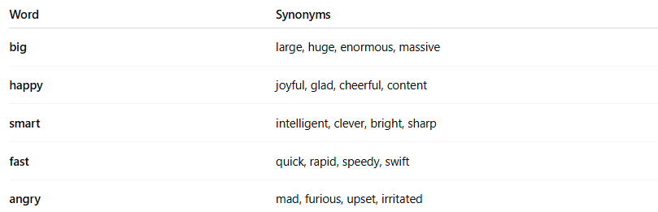

Word | Synonyms
big | large, huge, enormous, massive
happy | joyful, glad, cheerful, content
smart | intelligent, clever, bright, sharp
fast | quick, rapid, speedy, swift
angry | mad, furious, upset, irritated

⚠️ Note on Synonyms:
# Source: Chatgpt (GPT-4-turbo) at [7/23/2025]
- True synonyms (identical in every way) are rare.
- Some synonyms differ in:
  - Formality (e.g., start vs. commence)
  - Emotion or connotation (e.g., childish vs. youthful)
  - Usage in specific contexts (e.g., doctor vs. physician)

✅ Summary:
# Source: Chatgpt (GPT-4-turbo) at [7/23/2025]
A synonym is a word with a similar or identical meaning to another word.
Synonyms are useful for avoiding repetition and enhancing variety in writing or speech.

2-Antonym

🔄 What is an Antonym?
# Source: Chatgpt (GPT-4-turbo) at [7/30/2025]
An antonym is a word that has the opposite meaning of another word.

🔹 Definition:
# Source: Chatgpt (GPT-4-turbo) at [7/30/2025]
An antonym is a word that means the opposite of another word in meaning, degree, or direction.

🔸 Examples:
# Source: Chatgpt (GPT-4-turbo) at [7/30/2025]
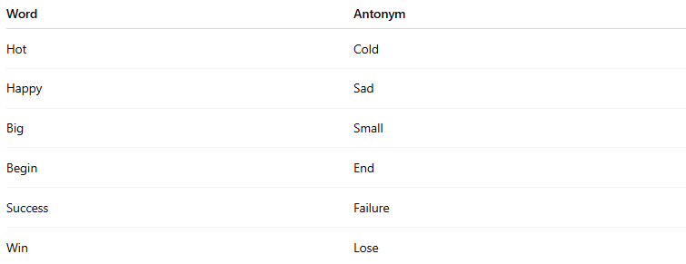
Word | Antonym
Hot | Cold
Happy | Sad
Big | Small
Begin | End
Success | Failure
Win | Lose

🔹 Types of Antonyms:
# Source: Chatgpt (GPT-4-turbo) at [7/30/2025]
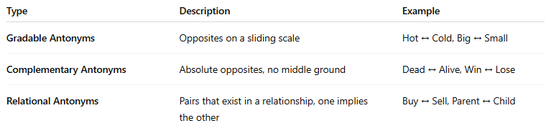
Type | Description | Example
Gradable Antonyms | Opposites on a sliding scale | Hot ↔ Cold, Big ↔ Small
Complementary Antonyms | Absolute opposites, no middle ground | Dead ↔ Alive, Win ↔ Lose
Relational Antonyms | Pairs that exist in a relationship, one implies the other | Buy ↔ Sell, Parent ↔ Child

🧠 Tip to Remember:
# Source: Chatgpt (GPT-4-turbo) at [7/30/2025]
If a synonym is a word with a similar meaning,
an antonym is a word with the opposite meaning.

3-Idiom

💬 What is an Idiom?
# Source: Chatgpt (GPT-4-turbo) at [7/23/2025]
An idiom is a phrase or expression whose meaning is different from the literal meaning of the individual words. It is a type of figurative language that is commonly used by native speakers and is often hard to understand just by translating word-for-word.

📘 Definition:
# Source: Chatgpt (GPT-4-turbo) at [7/23/2025]
An idiom is a fixed group of words or expression whose meaning is culturally understood and not directly deducible from the individual words.

🧠 Key Features of Idioms:
# Source: Chatgpt (GPT-4-turbo) at [7/23/2025]
- Non-literal meaning: The meaning is metaphorical, not the exact words.
- Fixed structure: Idioms usually have a set form (you can't change the words easily).
- Cultural: Native speakers understand them easily; learners must memorize them.

🔍 Examples of Common Idioms:
# Source: Chatgpt (GPT-4-turbo) at [7/23/2025]
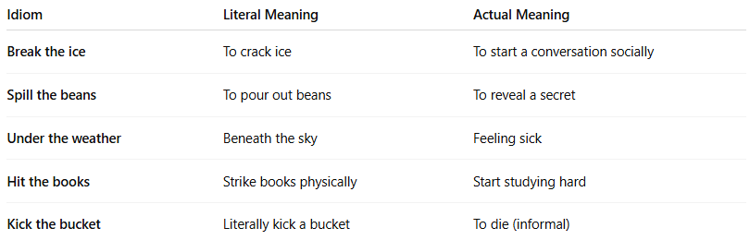

Idiom | Literal Meaning | Actual Meaning
Break the ice | To crack ice | To start a conversation socially
Spill the beans | To pour out beans | To reveal a secret
Under the weather | Beneath the sky | Feeling sick
Hit the books | Strike books physically | Start studying hard
Kick the bucket | Literally kick a bucket | To die (informal)

📚 Idioms in Language Learning:
# Source: Chatgpt (GPT-4-turbo) at [7/23/2025]
- Idioms are challenging for learners because you can’t translate them literally.
- They add color, naturalness, and fluency to speech and writing.
- Many idioms are based on culture, history, or metaphors.

🧾 Idiom vs. Metaphor vs. Expression:
# Source: Chatgpt (GPT-4-turbo) at [7/23/2025]
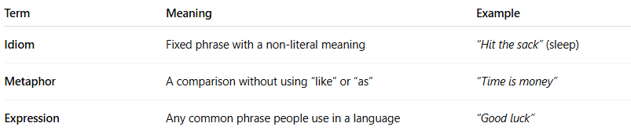

Term | Meaning | Example
Idiom | Fixed phrase with a non-literal meaning | “Hit the sack” (sleep)
Metaphor | A comparison without using “like” or “as” | “Time is money”
Expression | Any common phrase people use in a language | “Good luck”

✅ Summary:
# Source: Chatgpt (GPT-4-turbo) at [7/23/2025]
An idiom is a phrase whose real meaning is different from what the words say literally.
It’s a natural part of everyday language, especially in spoken English.

4-Expression

💬 What is an Expression?
# Source: Chatgpt (GPT-4-turbo) at [7/23/2025]
An expression in language is a word, phrase, or group of words used to convey a specific idea, feeling, or meaning. It can be literal or figurative and includes everything from basic greetings to complex idioms.

📘 Definition:
# Source: Chatgpt (GPT-4-turbo) at [7/23/2025]
An expression is any combination of words used to express thoughts, emotions, actions, or ideas in a meaningful way.

🧠 Key Points:
# Source: Chatgpt (GPT-4-turbo) at [7/23/2025]
- Expressions can be literal (direct meaning) or figurative (implied meaning).
- They include:
  - Fixed phrases (e.g., How are you?)
  - Idioms (e.g., It’s raining cats and dogs)
  - Collocations (e.g., make a decision)
  - Sayings/proverbs (e.g., Actions speak louder than words)

🔍 Examples of Expressions:
# Source: Chatgpt (GPT-4-turbo) at [7/23/2025]
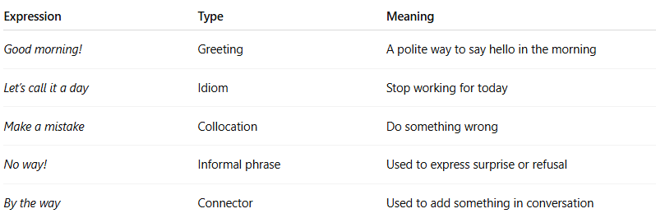

Expression | Type | Meaning
Good morning! | Greeting | A polite way to say hello in the morning
Let’s call it a day | Idiom | Stop working for today
Make a mistake | Collocation | Do something wrong
No way! | Informal phrase | Used to express surprise or refusal
By the way | Connector | Used to add something in conversation

🧾 Expression vs Idiom vs Phrase:
# Source: Chatgpt (GPT-4-turbo) at [7/23/2025]
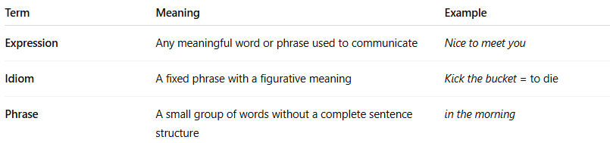
Term | Meaning | Example
Expression | Any meaningful word or phrase used to communicate | Nice to meet you
Idiom | A fixed phrase with a figurative meaning | Kick the bucket = to die
Phrase | A small group of words without a complete sentence structure | in the morning

✅ Summary:
# Source: Chatgpt (GPT-4-turbo) at [7/23/2025]
An expression is any common way of saying something, whether it’s formal, informal, literal, or figurative.
It helps speakers convey feelings, thoughts, and intentions clearly and naturally.

5-Homonyms

🔹 What Are Homonyms?
# Source: Chatgpt (GPT-4-turbo) at [8/1/2025]
Homonyms are words that have the same spelling or pronunciation, but different meanings. The term "homonym" is often used in a general sense, but technically it includes two major subtypes:

🧩 Types of Homonyms
# Source: Chatgpt (GPT-4-turbo) at [8/1/2025]
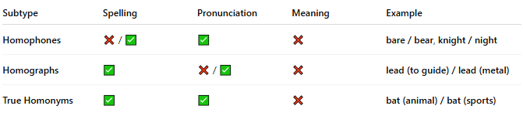
Subtype | Spelling | Pronunciation | Meaning | Example
Homophones | ❌ / ✅ | ✅ | ❌ | bare / bear, knight / night
Homographs | ✅ | ❌ / ✅ | ❌ | lead (to guide) / lead (metal)
True Homonyms | ✅ | ✅ | ❌ | bat (animal) / bat (sports)

📝 Examples by Type

🔹 Homophones (same sound, different meaning/spelling)
# Source: Chatgpt (GPT-4-turbo) at [8/1/2025]
- two / too / to
- flour / flower
- write / right

🔹 Homographs (same spelling, different sound/meaning)
# Source: Chatgpt (GPT-4-turbo) at [8/1/2025]
- tear (to rip) / tear (from eye)
- wind (air) / wind (to twist)

🔹 True Homonyms (same spelling and sound)
# Source: Chatgpt (GPT-4-turbo) at [8/1/2025]
- bat (animal) / bat (used in sports)
- bark (tree) / bark (dog sound)
- lie (to recline) / lie (to tell an untruth)

🧠 Why Are Homonyms Important?
# Source: Chatgpt (GPT-4-turbo) at [8/1/2025]
- Cause ambiguity and wordplay in language.
- Frequently used in puns, jokes, poetry, and riddles.
- Important in language learning and contextual understanding.

